**MINI PROJECT ON**

# SMART ACCIDENT DETECTION SYSTEM

GROUP MEMBERS

|  |  |  |
| --- | --- | --- |
| **SR.**  **NO.** | **STUDENT NAME** | **PRN** |
| 1 | NALAWADE ADARSH NAMDEO | 22410067 |
| 2 | PATIL ARYAN SURESH | 22410075 |
| 3 | SHAHAPURE TANMAY RAJENDRA | 22410077 |

**For**

**T. Y. B.Tech (Electronics Engineering)**

**Under the Guidance of**

**Dr. B.G.Patil (sir)**



**Department of Electronics Engineering**

**Walchand College of Engineering, Sangli**

**2024-25**



**Department of Electronics Engineering**

**Walchand College of Engineering, Sangli**

**2024-25**

# CERTIFICATE

This is to certify that the project titled **"Home automation system"** submitted by

|  |  |  |
| --- | --- | --- |
| **SR.**  **NO.** | **STUDENT NAME** | **PRN** |
| 1 | NALAWADE ADARSH NAMDEO | 22410067 |
| 2 | PATIL ARYAN SURESH | 22410075 |
| 3 | SHAHAPURE TANMAY RAJENDRA | 22410077 |

Students of Walchand College of Engineering, sangli, Third Year, department of electronics engineering has completed the Mini Project satisfactorily in course MINI PROJECT-II (6EN341) for the academic year 2024-25 as prescribed in the curriculum by Walchand College of Engineering.

**DATE : 12/11/2024**

**Guide External Examiner**

Dr. B.G. Patil (sir)

**Problem statement:**

The **Smart Accident Detection and Alert System** uses an **Arduino**, **piezoelectric sensor**, **GSM**, and **GPS modules** to automatically detect accidents by sensing pressure from collisions. Upon detecting an accident, the system sends an emergency SMS with the vehicle’s location to pre-defined contacts. This ensures faster emergency responses, particularly in remote areas, improving safety and potentially saving lives.

**Introduction:**

In recent years, road accidents have become a major global concern, causing thousands of fatalities and injuries annually. While emergency response systems have improved, the time it takes for authorities to respond to accidents remains critical to saving lives. Often, accidents go unnoticed or are reported too late, especially in remote areas where help might not reach quickly enough. Traditional methods of detecting accidents heavily rely on manual intervention, which can delay crucial actions.

The **Smart Accident Detection and Alert System** aims to address this issue by leveraging modern technology to automatically detect accidents in real-time. The system utilizes a **piezoelectric sensor** to sense abrupt pressure changes caused by a collision. As soon as an accident is detected, the system immediately activates and sends an emergency alert to pre-defined contacts or emergency services. This alert includes the precise **GPS coordinates** of the vehicle, allowing for quicker and more accurate response times.

The system is designed using an **Arduino** microcontroller, which interfaces with the piezoelectric sensor, the GSM module for communication, and the GPS module to capture real-time location data. This combination of components ensures that the system is both efficient and cost-effective, making it suitable for integration in everyday vehicles without significant modifications.

By automating the process of accident detection and alerting, the system minimizes human error and speeds up the emergency response. It is especially beneficial in cases where the driver is incapacitated or unable to communicate, such as in serious accidents or when driving in isolated regions. The goal is to reduce the time between an accident occurring and emergency services being notified, ultimately improving road safety and saving lives.

**Objectives:**

**1. Automatic Accident Detection**: To design a system that automatically detects accidents using a piezoelectric sensor based on pressure changes caused by collisions.

**2. Real-Time Location Tracking:** To integrate a GPS module that provides real-time location coordinates of the vehicle at the time of the accident.

**3. Instant Emergency Alerts:** To send an immediate emergency SMS alert with the vehicle’s location to predefined contacts or emergency services via the GSM module.

**4. Cost-Effective Implementation:** To design the system using affordable and easily accessible components like Arduino, piezoelectric sensors, GSM, and GPS modules.

**5. User-Friendly System:** To ensure the system is easy to install and operate without requiring complex user intervention or modifications to existing vehicle systems.

**6. Minimization of Human Error:** To eliminate the reliance on human intervention in accident detection and alerting, thereby improving the accuracy and reliability of the system**.**

**7. Improved Response Time**: To reduce the response time for emergency services by ensuring timely notifications, especially in remote or low-traffic areas.

**8. Scalability and Flexibility: T**o design the system in a way that can be easily integrated into different vehicle types, both private and commercial.

**9. Battery Efficiency:** To ensure the system operates efficiently with minimal power consumption, using the vehicle’s existing power source.

**10. Enhanced Road Safety:** To contribute to overall road safety by reducing fatalities and injuries through faster emergency response and detection of accidents.

**BLOCK DIAGRAM:**

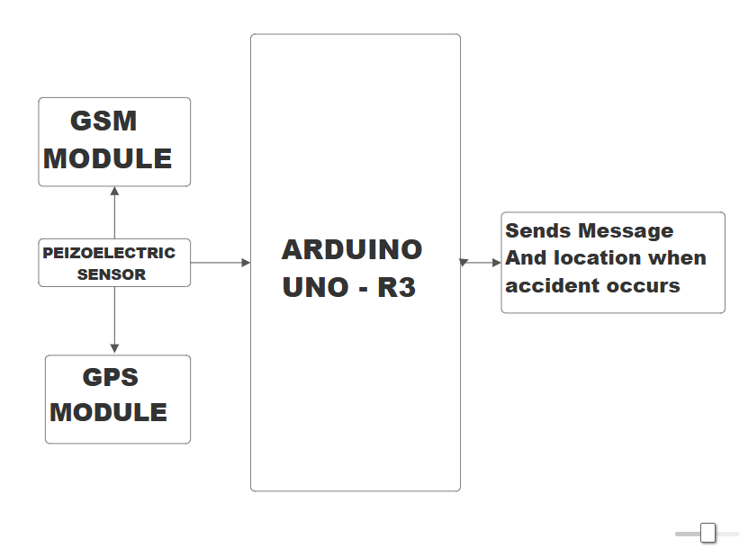

**KEYPOINTS:**

**1. Centralized Control:** Provides a unified system (app, vehicle display, etc.) to manage the accident detection process and alerts.

**2. Sensor Integration:** Uses sensors (piezoelectric sensor) to detect changes in the vehicle’s environment such as impact, pressure, or sudden movements**.**

**3. Data Analysis:** Analyzes sensor data to determine if an accident has occurred by checking for abnormal pressure, acceleration, or impact levels.

**4. Real-Time Alerts:** Sends immediate notifications to emergency contacts or services when an accident is detected.

**5. Automatic Location Sharing:** Uses GPS to automatically send real-time location coordinates of the vehicle to emergency responders or family members.

**6. Remote Access:** Allows emergency contacts to access the accident status and vehicle location remotely.

**7. Data Logging:** Records accident-related data such as time, impact, location, and severity for future reference or investigation.

**8. Increased Convenience:** Reduces response time for emergency services, ensuring faster medical or technical support after an accident**.**

**9. Enhanced Safety:** Provides immediate notifications and location data to minimize potential harm to the involved parties.

**10. Energy Efficiency:** Designed to operate on low power, consuming minimal energy while the vehicle is running or at rest.

**11. Improved Communication:** Facilitates direct communication between the vehicle, emergency services, and family members during an accident.

**12. Enhanced Accessibility:** Ensures that the system is easy to use and accessible for both drivers and passengers, especially in critical situations.

**13. Proactive Management:** Can anticipate and detect accidents early, providing preventative measures such as automatic airbags orsafety system engagement.

**14. Increased Vehicle Safety Value:** Enhances the vehicle’s safety features, adding value and increasing its desirability in the market.

**Components:**

**1.Arduino Uno :**

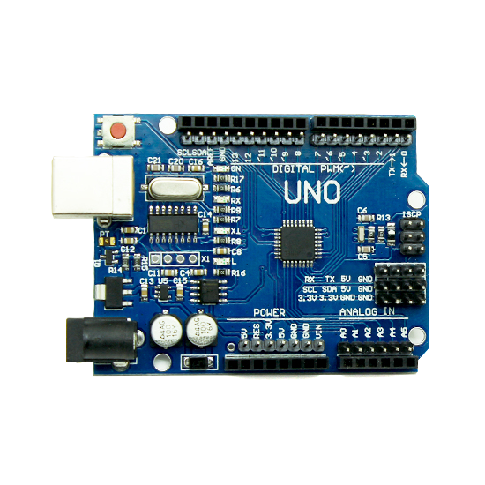

The Arduino UNO R3 is a microcontroller board .It's designed for projects that require a large number of input/output pins and more processing power than tother microcontroller.

**2.Sim 900A module :**

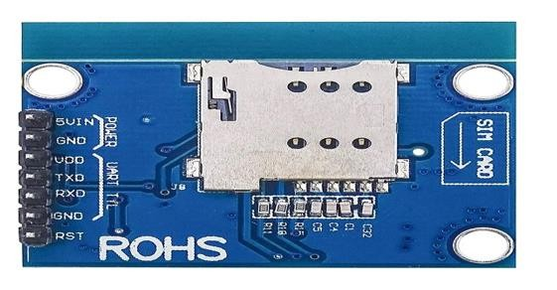

The SIM900A GSM module is a compact and cost-effective GSM/GPRS module developed by SIMCom, widely used in embedded electronics and IoT applications. It operates on dual-band GSM frequencies – 900 MHz and 1800 MHz – making it ideal for regions like Asia, Africa, and parts of Europe, but incompatible with North American GSM bands. The module supports both voice and SMS functionalities, allowing users to make/receive calls and send/receive messages through standard AT commands over a serial UART interface, with a default baud rate of 9600 bps (configurable as needed).

**3.NEO-6M GPS MODULE**

The **NEO-6M GPS module** is a high-performance GPS receiver developed by u-blox, commonly used in navigation and tracking applications. It offers precise positioning with an accuracy of up to **2.5 meters** and supports communication via **UART (serial interface)**. The module includes an onboard **ceramic antenna** (or supports an external one) and operates on **3.3V to 5V**, making it easy to interface with microcontrollers like **Arduino**. It also features a **backup battery (CR1220)** for storing last GPS data and faster cold starts. 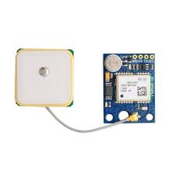

**4.PEIZOELECTRIC SENSOR**

A piezoelectric sensor is a device that converts mechanical stress, such as pressure or vibration, into an electrical signal using the piezoelectric effect. It is highly sensitive and responds quickly to changes, making it ideal for impact or collision detection. These sensors are compact, reliable, and widely used in applications like accident detection systems and vibration monitoring.



**Arduino Uno architecture:**

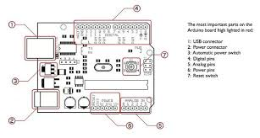

**ARDUINO UNO R3 Microcontroller:**

This is the core of the Arduino UNO R3. It's an 8-bit AVR RISC (Reduced Instruction Set Computer) microcontroller.

AVR architecture is known for its efficiency and relatively high performance.

**Memory:**

Flash Memory: 256 KB. This is where the program code is stored. A portion of this is used by the bootloader.

SRAM (Static Random-Access Memory): 8 KB. This is used for temporary data storage during program execution.

EEPROM (Electrically Erasable Programmable Read-Only Memory): 4 KB. This allows for long-term data storage that persists even when the power is off.

**Input/Output (I/O) Pins:**

The UNO R3 boasts a large number of I/O pins, which is a key feature:

Digital I/O Pins: 54 pins, allowing for digital input and output. 15 of these pins can provide PWM (Pulse Width Modulation) output, which is useful for controlling things like motor speed or LED brightness.

Analog Input Pins: 16 pins, which can read analog voltage levels.

**Communication Interfaces:**

UARTs (Universal Asynchronous Receiver/Transmitters): 4 hardware serial ports, enabling serial communication with other devices.

SPI (Serial Peripheral Interface): Allows for synchronous serial communication.

I2C (Inter-Integrated Circuit): Enables communication with devices using the I2C protocol.

**Clock Speed:**

The microcontroller operates at a clock speed of 16 MHz, which determines the speed at which it executes instructions.

**Power Supply:**

The board can be powered via a USB connection or an external power supply.

The board contains voltage regulators to provide the correct voltages to the microcontroller and other components.

The Arduino UNO R3’S architecture is designed to provide a versatile platform for complex projects. Its large number of I/O pins, ample memory, and various communication interfaces make it suitable for applications that require extensive control and data processing.

**WHY Arduino Uno?**

The Arduino Uno R3 is particularly well-suited for home automation systems due to its specific characteristics. Here's a breakdown of the key reasons:

1. **Abundance of I/O Pins:**

Home automation often involves numerous sensors and actuators. The Uno R3’s's large number of digital and analog I/O pins allows for the connection of a wide array of devices. This is crucial for controlling lights, appliances, sensors, and other components within a home.

1. **Multiple Serial Ports:**

The presence of multiple UARTs (serial ports) enables the Uno R3 to communicate with various devices simultaneously. This is valuable for:

Connecting to multiple sensors that use serial communication. with communication modules like Wi-Fi or Bluetooth.

Communicating with other microcontrollers or devices.

1. **Ample Memory:**

Home automation programs can become complex, especially when dealing with numerous sensors, control algorithms, and communication protocols. The Uno R3’s larger flash memory and SRAM provide sufficient space for these programs.

1. **Versatility and Flexibility:**

The Arduino platform, in general, is known for its versatility. The Uno R3 is no exception. It can be used to implement a wide range of home automation functions, from simple lighting control to complex climate control and security systems.

It is very adaptable to many different sensors and actuators.

1. **Cost-Effectiveness:**

Compared to industrial-grade automation controllers, the Arduino Uno R3 is relatively inexpensive. This makes it an attractive option for DIY enthusiasts and hobbyists looking to build their own home automation systems.

The Arduino Uno R3 combination of abundant I/O pins, multiple serial ports, ample memory, versatility, and cost-effectiveness makes it a strong choice for building robust and feature-rich home automation systems.

**Working:**

The Smart Accident Detection and Alert System is designed to automatically detect vehicle collisions and send emergency alerts with location details to predefined contacts. The core of this system is a **piezoelectric sensor**, which is mounted on the vehicle’s body to detect sudden impacts or pressure changes. When a collision occurs, the mechanical stress generated on the sensor produces an electrical signal. This signal is then analyzed by the microcontroller (such as Arduino) to determine whether it exceeds a predefined threshold, confirming a possible accident.

Once an accident is detected, the system activates the **NEO-6M GPS module**, which starts retrieving the **real-time coordinates (latitude and longitude)** of the vehicle. This information is crucial as it helps emergency services or family members to locate the accident spot quickly. The GPS data is continuously fetched and stored temporarily for transmission.

Simultaneously, the **SIM900A GSM module** is triggered to send an **SMS alert** to registered emergency contacts. The message includes a short description of the incident and the **exact GPS coordinates** obtained from the GPS module. In some implementations, the system can also make a call to ensure that the alert has been noticed. The GSM module uses standard AT commands to handle message transmission and voice calls.

This system works autonomously and in real-time, requiring no manual input once installed. Its combination of **impact detection, location tracking, and wireless communication** makes it an effective tool for **reducing response time** in road accidents, potentially saving lives. Additionally, the setup is cost-effective, making it suitable for widespread use in both personal and commercial vehicles.

**PROJECT RESOURCES :**

|  |  |  |
| --- | --- | --- |
| **SR.**  **NO.** | **Name of Resource** | **Resources unit** |
| 1. | Computer System | Hp intel i5(8 GB RAM) |
| 2. | software | Arduino IDE |
| 3. | Simulation Software | Proteus 8 |

**Advantages and challenges:**

Home automation systems offer a compelling blend of convenience and efficiency, but they also present certain challenges.

**Advantages:**

1. **Quick Emergency Response:** Automatically detects accidents and sends immediate alerts, reducing response time and potentially saving lives.

**2. Real-Time Location Tracking:** Provides accurate GPS coordinates of the accident site, helping emergency services reach the location faster.

**3. Fully Automated Operation:** Works without human intervention, ensuring alerts are sent even if the victim is unconscious or unable to act.

**4. Cost-Effective and Scalable:** Uses affordable components like the piezo sensor, GPS, and GSM modules, making it accessible for widespread use.

**5. Improved Road Safety:** Enhances vehicle safety by integrating collision detection with communication, promoting safer travel and faster assistance.

**HARDWARE IMPLEMENTATION :-**

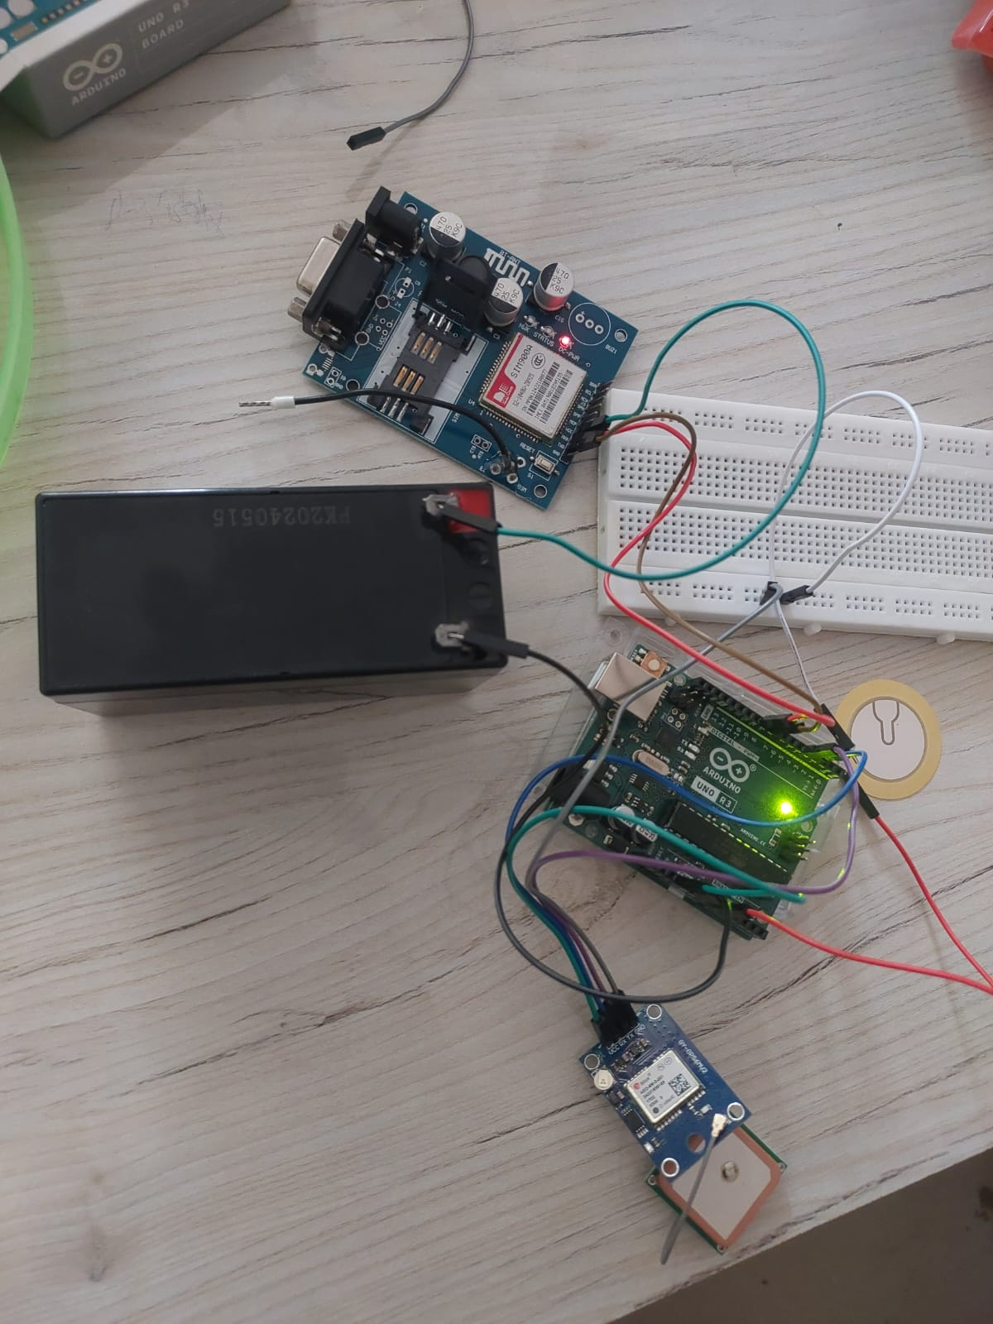

**Challenges:**

**1.Initial Cost and Complexity:** Setup and installation can be expensive and complex. Technical expertise may be required for installation and maintenance.

**2.Security Vulnerabilities:** Connected devices are susceptible to cyberattacks and unauthorized access. Protecting sensitive data and ensuring network security is crucial.

**3.Reliability and Compatibility:** System failures can disrupt daily routines. Ensuring compatibility between different devices and platforms can be challenging. Dependence on internet connectivity.

**4.Privacy Concerns:** Data collection and usage raise privacy concerns. Users must be aware of how their data is being used and protected.

**Application:**

• **Automobiles** – Installed in cars, bikes, and trucks to detect collisions and send emergency alerts.

• **Fleet Management** – Used by logistics and transportation companies to monitor accidents in delivery or transport vehicles.

• **Public Transport** – Ensures safety in buses and other public transport by alerting authorities in case of accidents.

• **Emergency Response Systems** – Integrated into emergency services to reduce response time and improve rescue efforts.

• **Smart Helmets** – Embedded in helmets for two-wheelers to detect head impacts and send alerts.

• **School Buses** – Enhances child safety by notifying parents or authorities if an accident occurs during transit.

• **Military and Defence Vehicles** – Used in armoured vehicles for immediate alerting during mission-critical accidents.

• **Remote Area Monitoring** – Valuable in rural or remote regions where accidents may otherwise go unnoticed for long periods.

**Conclusion:**

In conclusion, the **Smart Accident Detection and Alert System** offers a significant advancement in road safety and emergency response. By leveraging sensors like the **piezoelectric sensor**, **GPS**, and **GSM modules**, the system provides quick, automated accident detection and immediate alerts to emergency services and contacts. This reduces response times, ensures timely assistance, and improves the chances of survival in critical situations. Its cost-effectiveness and easy integration with existing vehicle systems make it accessible for widespread use, from personal cars to fleet management and public transportation. Moreover, the system’s ability to work autonomously enhances its reliability, particularly in situations where the victim is unable to respond. As part of the broader move towards **intelligent transportation systems**, this project offers a vital tool for enhancing vehicle safety and could play a pivotal role in reducing accident-related fatalities and injuries.